**Business performance**

Remember Kimbal's Business Dimensional Lifecycle principles:

* Focus on the business e.g. Identify business requirements and their associated value.
* Build an information infrastructure e.g. build a single, integrated, easy-to-use, high performance information foundation able to meet the business requirements.
* Deliver in meaningful increments e.g. 6 to 12 month timeframes.
* Deliver the entire solution e.g. provide all the elements necessary to deliver value to the business user e.g. data warehouse, ad hoc query tools, reporting applications, advanced analytics, training, support etc

**Business performance**

OLAP applications all require (1) multi-dimensional views of data, (2) support for complex calculations (such as forecasting), and (3) time intelligence. Time intelligence is a key feature of almost any analytical application as performance is almost always judged over time.

* Monitoring database performance ensures efficient query response times and resource utilisation.
* Kimball believes that the use of star schemas is a more intuitive way to model decision support data and furthermore can enhance performance for complex analytical queries.
* Consistent reporting performance is required in any BI tool.

<https://youtu.be/a-5oGmCLUQs>

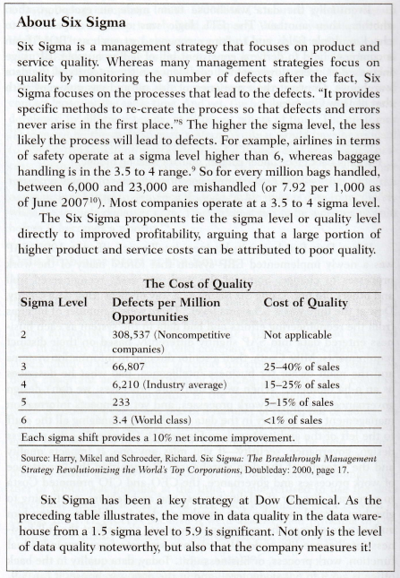

**Comparison of BSC and Six Sigma**

